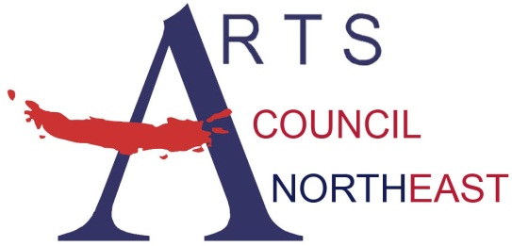
Contact: Bobbie McFarland
bmcfarland@artscouncilnortheast.org
817-283-3406, www.artscouncilnortheast.org

Arts Council Northeast and the City of Hurst present:

Havana NRG- Free Concert
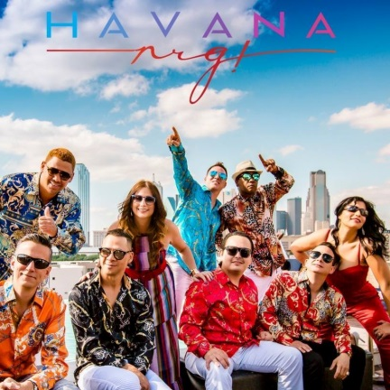

WHO: Havana NRG, Salsa
WHAT: MasterWorks Concert Series
FREE and OPEN to the public!

WHEN: Thursday, September 06, 2018

from 7:00pm-8:00pm

WHERE: Heritage Village Plaza - 837 W. Pipeline Rd

Hurst, Texas – Arts Council Northeast and the City of Hurst are pleased to welcome Havana NRG for a concert on Thursday, September 06, 2018 at the Heritage Village Plaza - 837 W. Pipeline Rd.
Celebrating over 15 years of great success, Havana NRG continues to be one of the strongest up-and-coming Latin orchestras of the world. Since the summer of 2002 not only have they performed in every major venue and public event in the State of Texas, they have also traveled to the surrounding states and as far as New York City, Los Angeles, Las Vegas, Miami and San Francisco. Havana NRG produced their debut CD, Camino al Cielo, which has become very popular in many US markets and in countries such as Japan, Italy, and others. Their debut CD also followed a video release in December of 2004. Havana NRG has proven that they are indeed "a new breed of Latin band," this New Rhythm Generation is taking their Cuban roots to new levels of performance and musical direction. Havana NRG credits their great success to not only a magnificent combination of fantastic musicians, but mainly to very supportive audiences everywhere.
Through the MasterWorks Series, Arts Council Northeast and the City of Hurst present free performances on selected evenings throughout the year. The MasterWorks Series is designed to offer a variety of quality family entertainment to the community by utilizing the talent of local, regional, and national artists.



