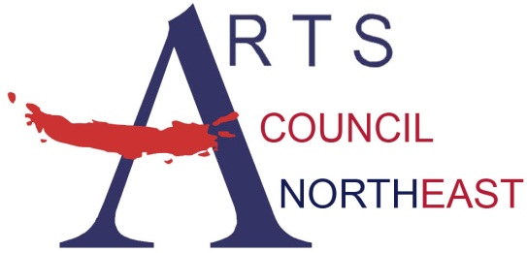
Contact: Bobbie McFarland
bmcfarland@artscouncilnortheast.org
817-283-3406, www.artscouncilnortheast.org

Arts Council Northeast and the City of Hurst present:

Cleghorn- Free Concert
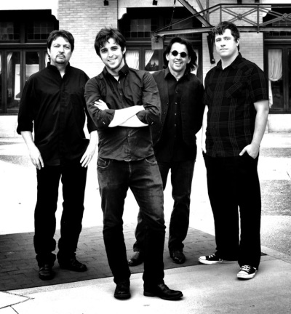

WHO: Cleghorn, Celtic Rock
WHAT: MasterWorks Concert Series
FREE and OPEN to the public!

WHEN: Thursday, September 27, 2018

from 7:00pm-8:00pm

WHERE: Hurst Library 901 Precinct Line Rd

Hurst, Texas – Arts Council Northeast and the City of Hurst are pleased to welcome Cleghorn for a concert on Thursday, September 27, 2018 at the Hurst Library 901 Precinct Line Rd.
CLEGHORN is America's Celtic Rock Band! The musical engine of CLEGHORN is renowned fiddler Dylan Cleghorn and his father, the legendary Texas guitarist John Cleghorn. CLEGHORN’s unique brand of “Celtic rock” mixes their original songwriting with high energy fiddle and bagpipe tunes.The Celtic Music News review of CLEGHORN's album states: "The robust and pristine sound of Dylan Cleghorn's fiddle is wrapped in heavy pop rock rhythms that approach anthemic intensity. John Cleghorn, adding his original songwriting, screaming guitar riffs and golden vocal melodies, reveals himself as a man who truly knows rock." The performances of CLEGHORN have enamored audiences and stirred up festivals across North America. Dylan and John have been acclaimed as charismatic performers who even go as far as leaving the stage to play among the crowd during their concerts. CLEGHORN promotes an energetic and uplifting show for all ages that should not be missed.
Through the MasterWorks Series, Arts Council Northeast and the City of Hurst present free performances on selected evenings throughout the year. The MasterWorks Series is designed to offer a variety of quality family entertainment to the community by utilizing the talent of local, regional, and national artists.



