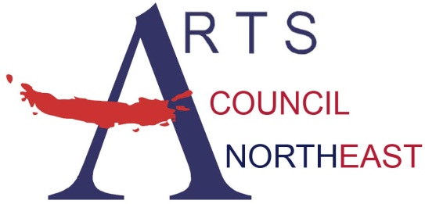
Contact: Bobbie McFarland
bmcfarland@artscouncilnortheast.org
817-283-3406, www.artscouncilnortheast.org

Arts Council Northeast and the City of Hurst present:

The After Party- Free Concert

WHO: The After Party, Top 40 Hits Variety
WHAT: MasterWorks Concert Series
FREE and OPEN to the public!

WHEN: Thursday, October 11, 2018

from 7:00pm-8:00pm

WHERE: Hurst Library 901 Precinct Line Rd

Hurst, Texas – Arts Council Northeast and the City of Hurst are pleased to welcome The After Party for a concert on Thursday, October 11, 2018 at the Hurst Library 901 Precinct Line Rd.
The real party doesn't start until The After Party takes the stage! The After Party performs the best Top 40 hits from today and yesterday with style and edge. With energetic and charismatic male and female singers, this 5 piece band has a wide variety of songs that engage the audience and keep dance floors packed all night long.
Through the MasterWorks Series, Arts Council Northeast and the City of Hurst present free performances on selected evenings throughout the year. The MasterWorks Series is designed to offer a variety of quality family entertainment to the community by utilizing the talent of local, regional, and national artists.



