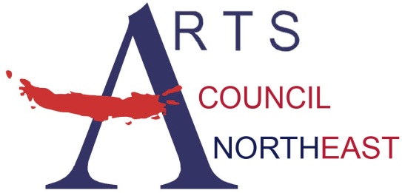
Contact: Bobbie McFarland
bmcfarland@artscouncilnortheast.org
817-283-3406, www.artscouncilnortheast.org

Arts Council Northeast and the City of Southlake present:

Southlake Community Band- Free Concert

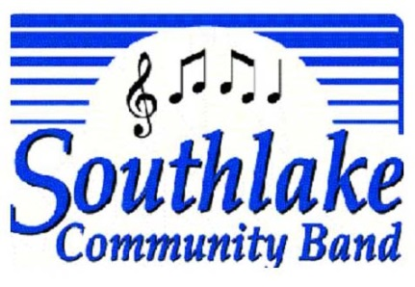
WHO: Southlake Community Band, Variety Wind Ensemble

WHAT: MasterWorks Concert Series
FREE and OPEN to the public!

WHEN: September 22, 2018 from 7:00PM -8:30PM

WHERE: Rustin Pavilion at Southlake Town Square (1400 Main Street, Southlake, TX 76092)

Southlake, Texas – Arts Council Northeast and the City of Southlake are pleased to welcome Southlake Community Band for a concert on September 22, 2018 at the Rustin Pavilion at Southlake Town Square (1400 Main Street, Southlake, TX 76092).
Southlake Community Band, directed by Mr. David Stone, is a concert band of more than seventy talented adult amateur musicians who enjoy playing music just for fun. The band performs regularly in the North Texas area cities Of Southlake, Grapevine, Keller, Colleyville and surrounding communities. Their concert programs range from classic band to Broadway, rousing Sousa marches to familiar children’s music.
Through the MasterWorks Series, Arts Council Northeast and the City of Southlake present free performances on selected evenings throughout the year. The MasterWorks Series is designed to offer a variety of quality family entertainment to the community by utilizing the talent of local, regional, and national artists.



