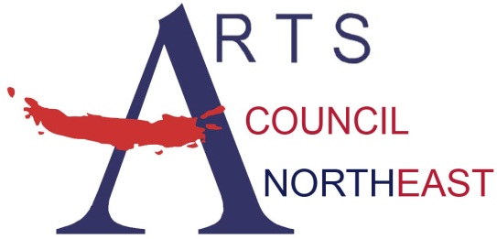
Contact: Bobbie McFarland
bmcfarland@artscouncilnortheast.org
817-283-3406, www.artscouncilnortheast.org

Arts Council Northeast and the City of Roanoke present:

Zack King- Free Concert

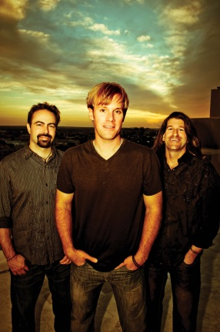
WHO: Zack King, Rock & Roll

WHAT: MasterWorks Concert Series
FREE and OPEN to the public!

WHEN: Thursday, September 20, 2018 from 7:00 - 8:00pm

WHERE: Austin Street Plaza Corner of Oak & Austin St

Roanoke, Texas – Arts Council Northeast and the City of Roanoke are pleased to welcome Zack King for a concert on Thursday, September 20, 2018 at the Austin Street Plaza Corner of Oak & Austin St.
Zack King and his band have been performing their unique brand of Texas Rock across the U.S. for over 10 years. In that time they have played with some of the most illustrious superstars in rock and country music. They kicked off their career opening for legendary singer/songwriter Leon Russell and have since performed with the likes of Bon Jovi, Alabama, Chris Cagle, Bret Michaels, Randy Travis, Keith Anderson, Kevin Fowler, Stone Temple Pilots, Tesla, Ronnie Milsap and many more. The NHL’s Dallas Stars have been using Zack King songs for years both at Dallas’ American Airlines Center during home games as well as in advertising and promotion for the team. Most recently, the band’s single “What Do You Say” is being used by CBS Television in Dallas/Fort Worth to promote current programming. Their song “Big Plan in the Southland” is the theme song for CBS’ DFW Outdoorsman featuring former Dallas Cowboy Marcus Spears.
Through the MasterWorks Series, Arts Council Northeast and the City of Roanoke present free performances on selected evenings throughout the year. The MasterWorks Series is designed to offer a variety of quality family entertainment to the community by utilizing the talent of local, regional, and national artists.



