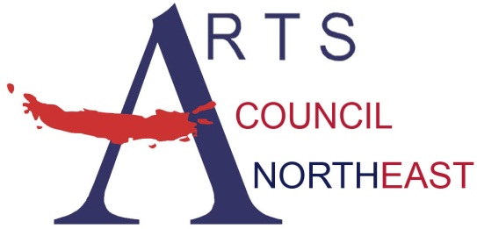
Contact: Bobbie McFarland
bmcfarland@artscouncilnortheast.org
817-283-3406, www.artscouncilnortheast.org

Arts Council Northeast and the City of Roanoke present:

Whitehouse Harmony- Free Concert

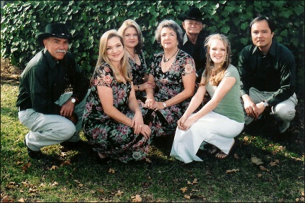
WHO: Whitehouse Harmony, Bluegrass

WHAT: MasterWorks Concert Series
FREE and OPEN to the public!

WHEN: Thursday, September 06, 2018 from 7:00 - 8:00pm

WHERE: Austin Street Plaza Corner of Oak & Austin St

Roanoke, Texas – Arts Council Northeast and the City of Roanoke are pleased to welcome Whitehouse Harmony for a concert on 9/6/2018 at the Austin Street Plaza Corner of Oak & Austin St.
Mention traditional or mountain music from the past and you may have visions of family groups singing on the front porch of their mountain home or at a church picnic under a spreading oak tree. Whitehouse Harmony is an accomplished Bluegrass band and will provide a well-balanced, entertaining show filled with the purest of harmony vocals, mountain clogging and great instrumentalist.
Through the MasterWorks Series, Arts Council Northeast and the City of Roanoke present free performances on selected evenings throughout the year. The MasterWorks Series is designed to offer a variety of quality family entertainment to the community by utilizing the talent of local, regional, and national artists.



